Title : Signal Processing

Course: E&EE Final Year

Date: 23_03_2001

A low pass analogue filter is required to have a 3dB cut off at 2kHz and 40dB per decade roll-off.

- ABSTRACT

Two methods of filter design have been studied and justified using theoretical arguments and MATLAB. The first requires the designer to evaluate through trial and error the location of poles and zeros on the s-plane. The Frequency response is evaluated in each case. Once the response is correct to the specification the system transfer function can then be taken directly from the pole zero map. The second approach relies on Classical filter prototype design investigation. Using common filter prototypes such as the Butterworth, Chebyshev and elliptic, the designer can select a response and by using standard tables create the system transfer function. The effectiveness of both approaches are compared and contrasted in the latter stages of the report.

- INTRODUCTION

The amplitude response at any frequency ω_{x} can be obtained from any pole-zero plot by taking the product of the lengths from point jω_{x} to the zeros and dividing it by taking the product of the lengths from point jω_{x} to the poles.

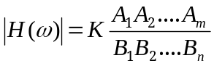

In a similar manner the phase response of the system at any frequency ω_{x} can be obtained from any pole-zero plot by taking the sum of the angles of the vectors from point jω_{x} to the zeros, and subtracting from it the sum of the angles of the vectors from point jω_{x} to the poles.

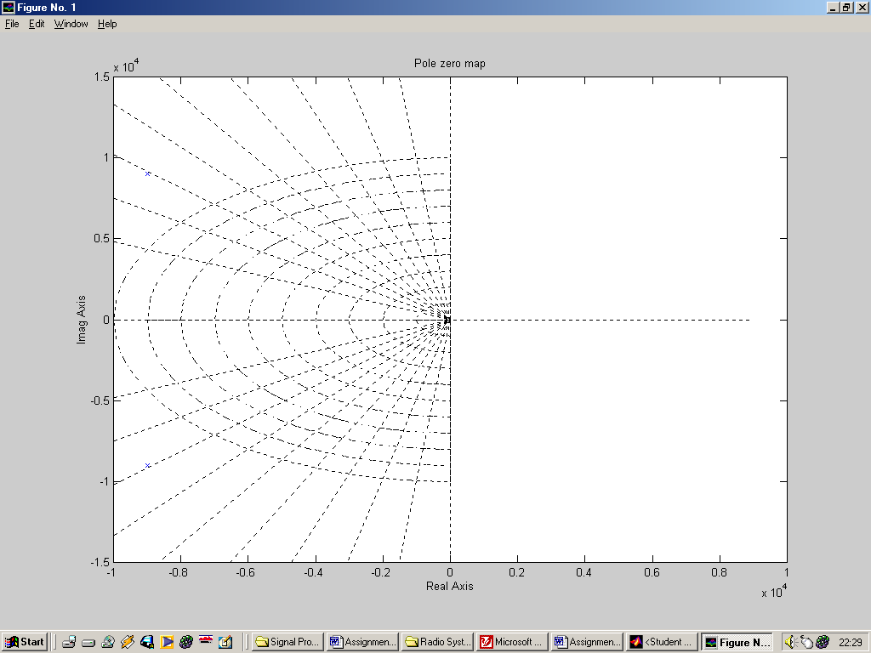
B1
B2
A2
β1
α2
A1
α1
β1
Figure(1.1) Determination of amplitude Figure(1.2) Determination of phase

Response from a pole-zero plot Response from a pole-zero plot

There are many frequency responses that have been studied, but the best known of these are the Butterworth, Chebyshev and elliptic function responses. In there lowpass form these are intended to give a near constant attenuation in most of the band up to the specified cut-off frequency, followed by a rapid increase in attenuation above this frequency.

RESULTS/DISCUSSIONS OF RESULTS

Part 1 – Arbitrary pole and zero placement on the s-plane

i). Choose a pair of poles

To achieve a roll-off equal to 40dB per decade a 2nd order filter is required i.e. one which has two poles in it’s polynomial transfer function.
The low pass filter is required to pass frequencies below 2kHz, which is equivalent to the radian frequency calculated below.

ω = 2 x pi x f = 2 x 3.14 x 2x10³ = 12.566 x 10³ rads⁻¹

So as a starting point a pair of conjugate poles placed at +- the radian cut off frequency will be placed on the jω axis.

ii). Evaluating H(jω) for this pair of conjugate poles

Shown in Figure(1.3) is a pole zero map of the initial transfer function. The symbolic poles are very faint, but on close inspection they occur at +-12566 on the jω axis. This map is created in MATLAB using the following command:-
MATLAB SCRIPT 1.1

z=[];
p=[+12566j, -12566j];
k=1;
[num, den]=zp2tf(z, p, k);
pzmap(num, den)

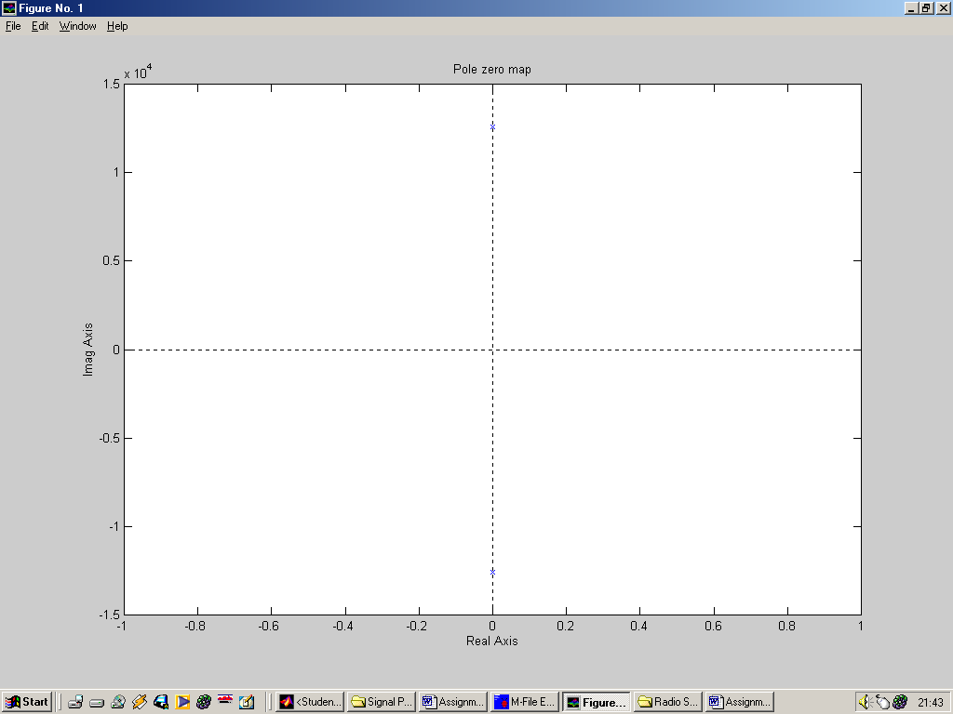

Figure(1.3) A pair of conjugate poles at +-12.566 x 10³ on the jω axis

The transfer function H(jω) will be constructed graphically from the pole zero plots. The transfer function will be evaluated from 0.5 rads⁻¹ to 1 x 10⁴ rads⁻¹ in steps of 0.5 x 10^{n+1} rads⁻¹.
Initially the frequency response of the filter will be evaluated at a radian frequency ω of 0.5 rads⁻¹. The distance from each of the poles (B₁, B₂) to the specified ω value are then calculated.

ω = 0.5 rads⁻¹
B1
B2
ω_{c} = 12566 rads⁻¹

Figure(1.4) Geometric construction for determining amplitude response of the low pass filter

Looking at Figure (1.4),
the distance B1 (from the pole to the chosen ω value) is:-
B1 = 12.566 x 10³ – 0.5 = 12.565

the distance B2 (from the pole to the chosen ω value) is:-
B2 = 12.566 x 10³ + 0.5 = 12.567

Using the equation below to solve the frequency response we have:-
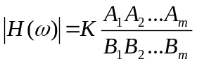

where A is the distance from the chosen ω to the zeros and B is the distance from the chosen ω to the poles. The phase response will be evaluated later.
Because there are no zeros in the chosen transfer function, the numerator of the frequency response becomes 1. K is also assumed to be 1, i.e. no amplification is present in this system.

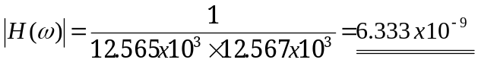

Note: H(ω) is a ratio, hence has no units.

Now the procedure for finding the amplitude of a system is known the amplitude response of a system can be tabulated for a given value of ω.

ω (rads⁻¹) | H(ω)
0.5 | 6.333x10⁻⁹
1.0 | 6.333x10⁻⁹
5.0 | 6.333x10⁻⁹
10.0 | 6.333x10⁻⁹
50.0 | 6.333x10⁻⁹
100.0 | 6.333x10⁻⁹
500.0 | 6.343x10⁻⁹
1000.0 | 6.373x10⁻⁹
5000.0 | 7.524x10⁻⁹
10000.0 | 1.727x10⁻⁸
12566.0 – cut off frequency | infinity
20000.0 | 4.131x10⁻⁹
50000.0 | 4.270x10⁻¹⁰
100000.0 | 1.016x10⁻¹⁰

To complete the frequency response the phase angle of each pole (and zero) with respect to zero must be calculated.

β1
β2
ω = 0.5 rads⁻¹
ω_{c} = 12566 rads⁻¹

Figure(1.5) Geometric construction for determining phase response of the low pass filter

Looking at Figure(1.5)

Both phase angles do not need to be calculated, their phase angles are obvious from the pole zero map.

The phase angle β1 = 270º

The phase angle β2 = 90º

∆H(ω) = β1 + β2 = 270 + 90 = 360º = 0º

From ω = 0 to ω_{c}(12566 rads⁻¹) the phase angle of the output signal remains in phase with the input i.e. 0º change. For frequencies ω > 12566 rads⁻¹ the phase angle of β1 will be 90º with respect to ω (β2 remains constant), which cumulatively means the output signal will be 180º out of phase with the output.

∆H(ω) = β1 + β2 = 90 + 90 = 180º

Plotting the phase response and magnitude response on log-log graph paper using a graph package the results would look similar to that shown in Figure(1.6).

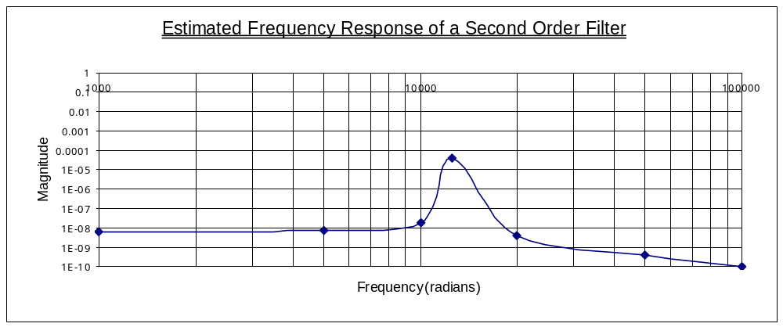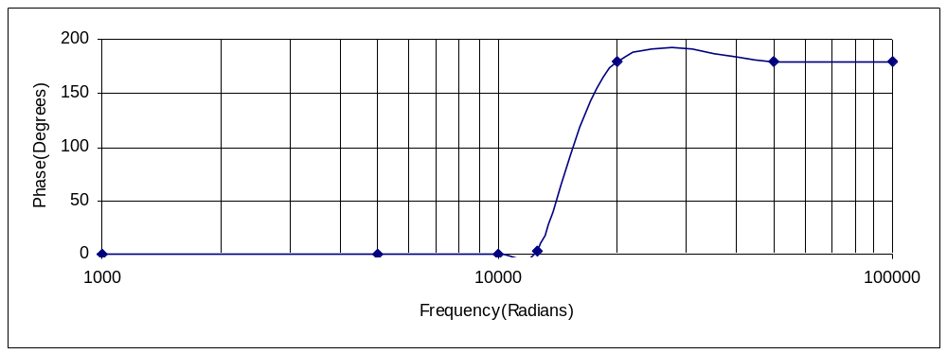
Figure(1.6) Estimated frequency response of the 2nd order low pass test filter

In Figure(1.6) it can be seen that the filter has a nice flat amplitude response at approximately 1x10⁻⁸ at radian frequencies up to 10kHz. At this point the output amplitude increases dramatically up to it’s maximum amplitude of approximately 5x10⁻⁵ (which is used as an indication of infinity) at 12kHz (the resonant frequency). The amplitude response then tails off at a fast constant rate up to a frequency of approximately 20kHz. After this point the response tails off at a constant rate 10^{n-1} per decade.
The phase response of the output of the system remains constant at a value of 0º up to a frequency of approximately 13000 rads⁻¹ (the magnitude of the poles). At that point up to a frequency of approximately 18000 rads⁻¹ the phase response increases at a fast rate up to a maximum value of 180º. After this point the phase response remains constant at 180º.
Shown below is a MATLAB script and results for the given transfer function specified above.
MATLAB SCRIPT 1.2

z=[];
p=[+12566j, -12566j];
k=1;
[num, den]=zp2tf(z, p, k);
Freqs(num,den);

The resultant frequency response can be observed in Figure(1.7)

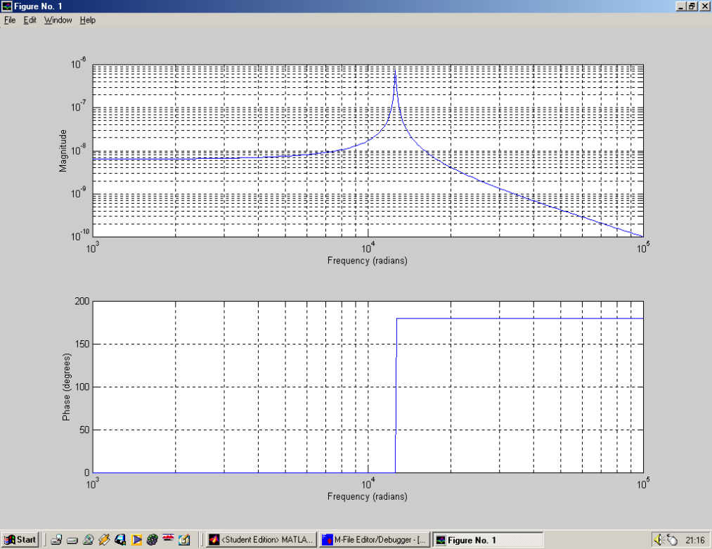

Figure(1.7) Actual frequency response of the 2nd order system using MATLAB

Figure(1.6) compares faithfully to Figure(1.7) in many respects. The graphical estimate reproduces the shape, but the magnitude of the amplitude response is not so faithfully reproduced. There is a smoother transition achieved in the Microsoft Excel phase response plot from 0º to 180º, this should be a straight vertical line. In any case, looking soley at the MATLAB response, it can be seen that a frequency of 2kHz is not filtered out by the system.

iii) Adjusting by trial and error the location of the location of the poles until the frequency response is as required

Revision 1

In Figure(1.7) it can be seen that the maxima amplitude response occurs at the specified cut off frequency which is also the magnitude of one of the conjugate poles. To cut out a frequency of 2kHz, the previous responses maxima requires shifting to the left so it occurs at approximately 9000 rad/s. When the poles of the system are now placed at +- j9000, the frequency of 2kHz should be filtered out. Again repeating steps i) and ii).

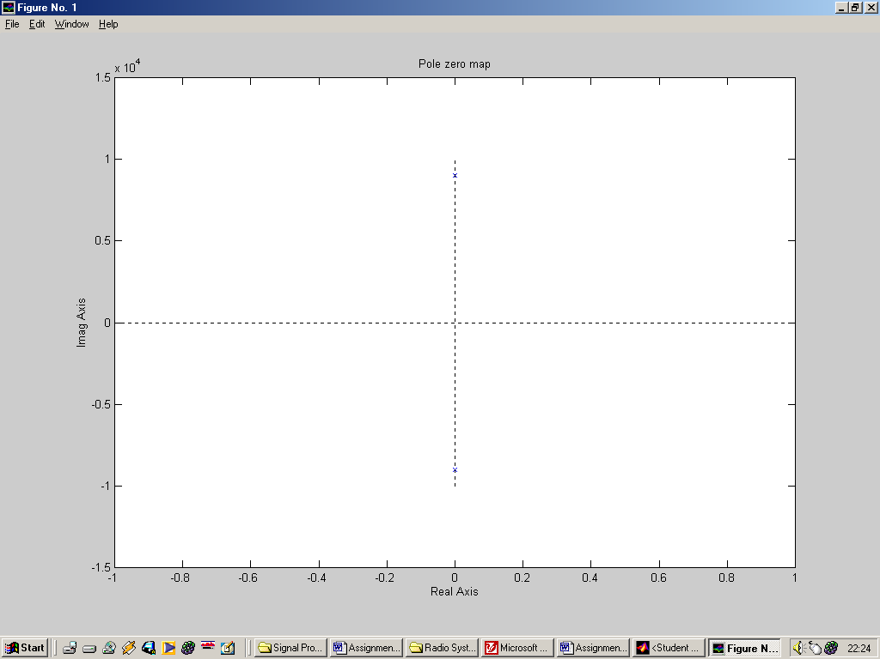
ω = 0.5 rads⁻¹
B1
B2
ω_{c} = 12566 rads⁻¹

Figure(1.8) Revised Geometric construction for determining amplitude response of the low pass filter

Looking at Figure(1.8),
the distance B1 (from the pole to the chosen ω value) is:-
B1 = 9 x 10³ – 0.5 = 8999

the distance B2 (from the pole to the chosen ω value) is:-
B2 = 9 x 10³ + 0.5 = 9001

Using the equation below to solve the frequency response we have:-
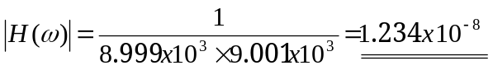

Using the same procedure, the amplitude response of a system can be tabulated for a given value of ω.

ω (rads⁻¹) | H(ω)
0.5 | 1.234x10⁻⁸
1.0 | 1.234x10⁻⁸
5.0 | 1.235x10⁻⁸
10.0 | 1.235x10⁻⁸
50.0 | 1.235x10⁻⁸
100.0 | 1.235x10⁻⁸
500.0 | 1.238x10⁻⁸
1000.0 | 1.205x10⁻⁸
2000.0 | 1.299x10⁻⁸
5000.0 | 1.786x10⁻⁸
9000.0 | infinity
10000.0 | 5.26x10⁻⁸
500000.0 | 4.134x10⁻¹⁰

Of course the frequency response would not be complete without the phase response. Taking into consideration the previous phase response, because the poles are again on the jω axis a similar phase response will be encountered. This time however a change in phase of the output from 0º to 180º will occur at ω = 9000 rads⁻¹ (as apposed to 12566).

These values, if plotted on log-log graph paper would look similar to that shown in Figure(1.9).

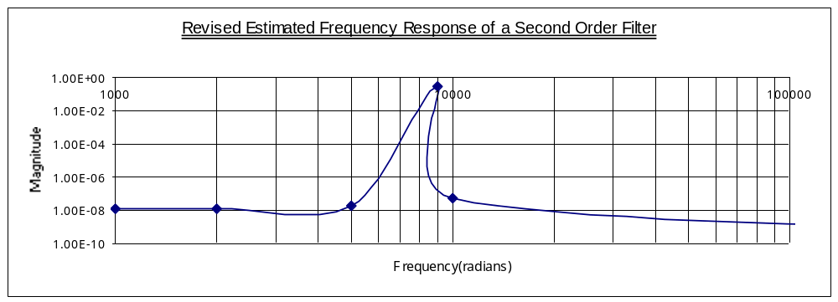
Figure(1.9a) Revised estimated amplitude response of the 2nd order low pass test filter

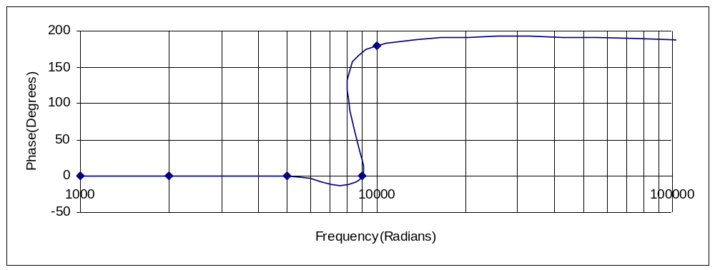
Figure(1.9b) Revised estimated phase response of the 2nd order low pass test filter

In Figures(1.9a) it can be seen that the filter has a nice flat response at approximately 1x10⁻⁸ (very similar amplitude response to that shown in Figure (1.6)) at radian frequencies up to 7000 rad/s (3000 rad/s down scale from previous trial). At this point the output amplitude increases dramatically up to it’s maximum of 1, which is again a representation of infinity (the resonant frequency). The amplitude response then tails off at a fast constant rate.
Figure(1.9b) gives an indication of the systems phase response to an incoming input sinusoid. Again there is a phase change in the output signal from 0 to 180º when the frequency of the input sinusoid is altered from frequencies of 0 to infinity. However this change in phase now occurs at a radian frequency of approximately 10000 rads⁻¹.

Shown below is a MATLAB script and results for the given transfer function specified above.

MATLAB SCRIPT 1.2

z=[];
p=[+9000j, -9000j];
k=1;
[num, den]=zp2tf(z, p, k);
Freqs(num,den);

The resultant frequency response can be observed in Figure(1.10)

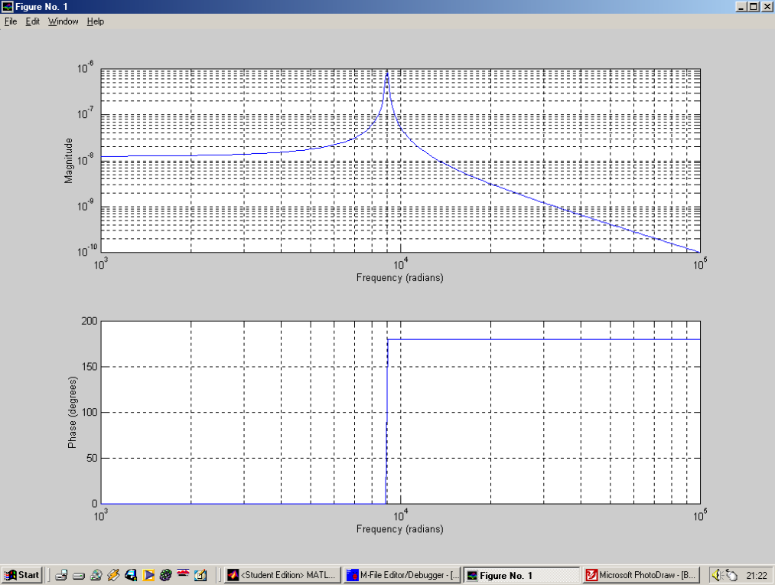

Figure (1.10) Actual revision 1 frequency response of the 2nd order system using MATLAB

Again the graphical amplitude response is faithful to that of the MATLAB revised response. The cut off frequency has got to be 3dB’s down from the pass band. So lets now look at the Matlab Bode Plot Amplitude Response, the Bode plot will give the amplitude response in dB’s.

MATLAB SCRIPT 1.3

z=[];
p=[+9000j, -9000j];
k=1;
[num, den]=zp2tf(z, p, k);
Bode(num,den);

The resultant frequency response can be observed in Figure(1.11)
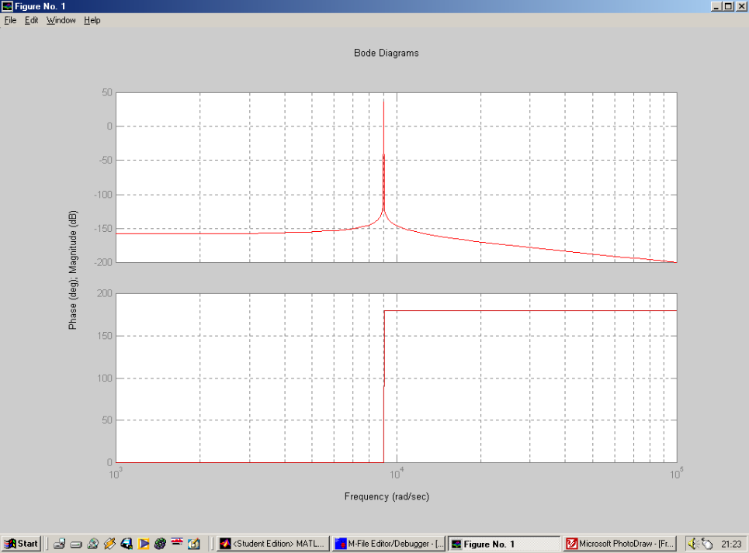

Figure(1.11) Bode Plot of 2nd order system response using MATLAB

In Figure(1.11) it can be seen that frequencies above approximately 1.5x10⁻⁴ rad/s are filtered out i.e. these frequencies are 3dB down from that of the steady state pass band magnitude. Seeing as this is approximating method the values of the poles used are correct to an extent. At the present moment in time the poles are placed on the jω axis, there is no real part to the poles used. Taking time to take in what has happened to the frequency response, for the previous values of the poles. It can be seen that when ω is varied, and when ω is equal in magnitude to the pole on the jω axis, the amplitude response shoots off to infinity. Hence the observed resonant peak visible in Figures(1.7), (1.9) and (1.10). Now to be rid of the resonant peak the conjugate poles require a sigma value. Taking into consideration the Nyquist stability criterion, i.e. The system is stable if all the poles lie in the left hand s-plane. The poles therefore must have negative real parts, how large the real parts must be is up to me the designer.

Revision 2

Many sigma values have been evaluated, if the sigma value is the same magnitude as the imaginary component i.e. –9000 the resultant frequency response graph is found to be correct. Hence this revision of the low pass filter system will have poles at a sigma value of -9000. This should in theory cause the resonant peak to flatten completely as evaluated.

ω = 0.5 rads⁻¹
B1
B2
ω_{c} = 12566 rads⁻¹

Figure(1.12) Revision 2, Geometric construction for determining amplitude response of the low pass filter

Looking at Figure(1.12),
the distance B1 (from the pole to the chosen ω value) is:-
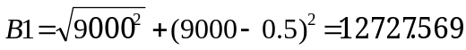

the distance B2 (from the pole to the chosen ω value) is:-
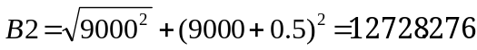

Using the equation below to solve the frequency response we have:-
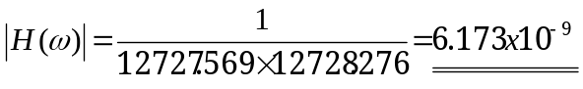

From the plot that follows the phase response can be estimated. Because the poles used have real –ve components, the phase calculation will require use of simple trigonometry.

ω = 0.5 rads⁻¹
β1
ω_{c} = 12566 rads⁻¹
β2
9000
9005
8995

Figure(1.13) Revision 2, Geometric construction for determining phase response of the low pass filter

Looking at Figure(1.13), and evaluating for ω = 0.5
the phase angle β2 (from a reference value of 0º) is:-
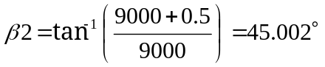

the phase angle β1 (from a reference value of 0º) is:-
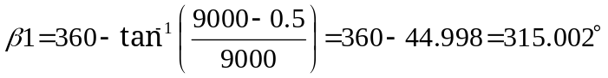

Using the equation below to solve the frequency response we have:-

Now the method are known, the phase and amplitude response of the output of the system can be tabulated for different values of the radian frequency ω.

ω (rads⁻¹) | H(ω) | Δ H(ω) (degrees)
0.5 | 6.173x10⁻⁹ | -0.004
1.0 | 6.173x10⁻⁹ | -0.006
5.0 | 6.174x10⁻⁹ | -0.032
10.0 | 6.173x10⁻⁹ | -0.064
50.0 | 6.139x10⁻⁹ | -0.318
100.0 | 6.173x10⁻⁹ | -0.637
500.0 | 6.173x10⁻⁹ | -3.185
1000.0 | 6.173x10⁻⁹ | -6.379
2000.0 | 6.171x10⁻⁹ | -12.836
5000.0 | 6.422x10⁻⁹ | -33.302
9000.0 | 5.521x10⁻⁹ | -63.435
10000.0 | 5.253x10⁻⁹ | -70.994
50000.0 | 3.992x10⁻¹⁰ | -158.946
100000.0 | 9.999x10⁻¹¹ | -169.632

These values, if plotted on log-log graph paper would look similar to that shown below.

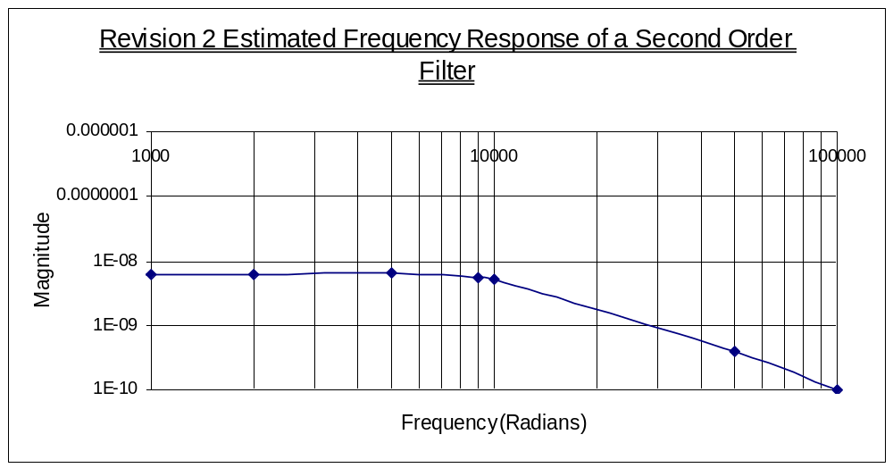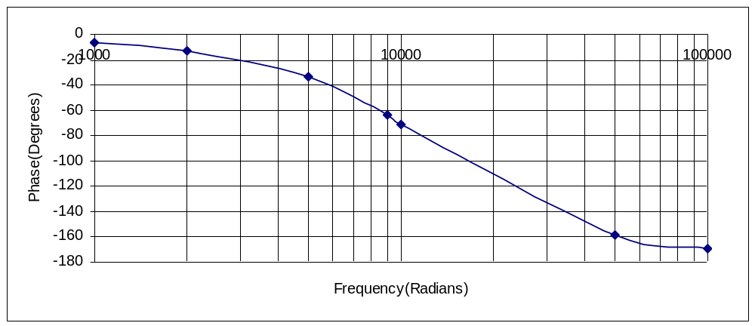
Figure(1.14) Revised estimated frequency response of the 2nd order low pass test filter

In Figure(1.14) it can be seen that the filter has a nice flat amplitude response at approximately 1x10⁻⁸ at radian frequencies up to 9000 rad/s. At this point the output amplitude increases dramatically up to it’s maximum amplitude of 1 (the resonant frequency). The amplitude response then tails off at a fast constant rate.
The phase response of Figure(1.14) differs from that of previous revisions in that the polarity is negative i.e. With an increase in ω from 0 to infinity, the phase response varies from 0 to -180º. Hence when the poles of the transfer function have a negative real part the phase of the output also becomes negative.

Shown below is a MATLAB script and results for the given transfer function specified above.

MATLAB SCRIPT 1.4

z=[];
p=[9000+9000j, 9000-9000j];
k=1;
[num, den]=zp2tf(z, p, k);
Bode(num,den);

The resultant Bode frequency response can be observed in Figure(1.15)

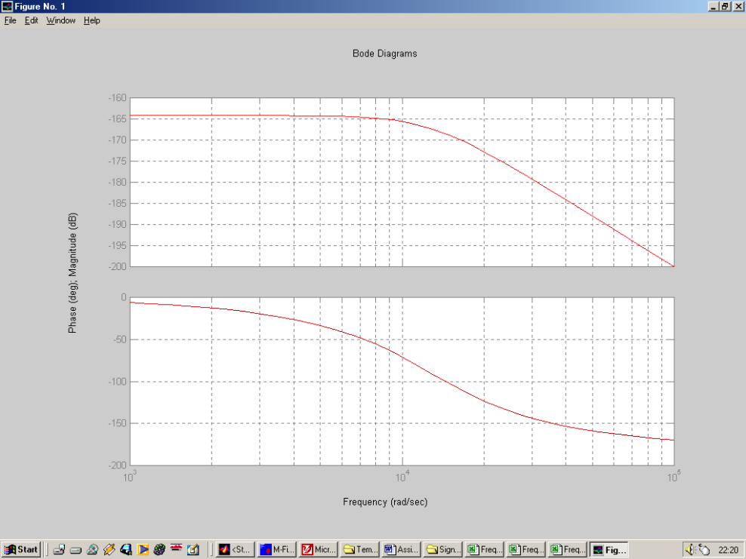

Figure(1.15) Bode Plot of 2nd order system response using MATLAB

Figure(1.15) shows the Bode plot for the 2nd and final revision of the low pass filter. The amplitude response is now correct. There is a nice flat pass band up to the corner frequency of approximately 10kHz. From this frequency onwards the amplitude response drops smoothly , at 3dB down from the pass band the frequency is approximately 13kHz. This matches the cut off frequency criteria stated in the Assignment question. The roll-off rate, is as stated 40dB per decade.

iv). Determining H(s) in polynomial form

H(s) can be simply determined directly from MATLAB SCRIPT 4. In the transfer function there are no zeros, the poles are at –9000+-j9000 hence:-

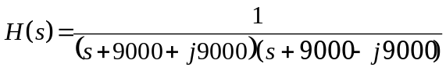

Multiply the denominator out we achieve:-

Gathering terms
Equation(1.1)
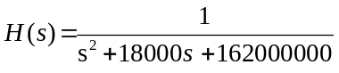

v). Computing Appropriate values of L, R & C to fulfil this design

The electrical circuit required to implement a second order passive low pass filter is shown in Figure(1.16). The derivation of it’s transfer function is also described.
R
L
C
V_{in}
V_{out}

Figure(1.16) Circuit configuration for a passive low pass filter

The transfer function for a 2nd order LC low pass filter network is

The transient governing circuit equations are:-

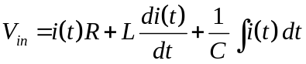
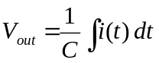

Taking the laplace transforms of both equations

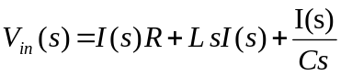
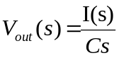
The transfer function of the network is just in this case the output voltage divided by the input voltage.

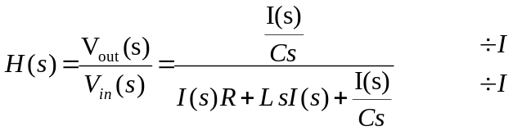

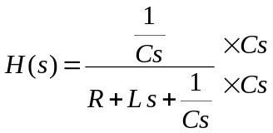

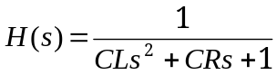

The transfer function as it stands is in the incorrect form, by dividing the numerator and denominator by the constant in front of the s

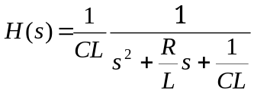
Equation(1.2)

Substituting values from Equation(1.1) into Equation(2.2), the values of L and C can be computed

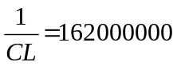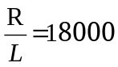

Choosing the inductance L value to be 10mH,

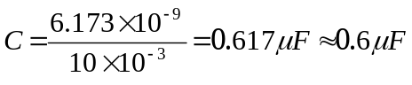
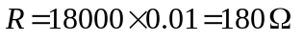

Hence the full set circuit component values are

L = 10mH C = 0.6μF R=180Ω

PART 2 – CLASSICAL FILTER DESIGN

i). Select an amplitude response for a low pass filter which is acceptable from those that exist, assuming the cut-off frequency will be 1 rad/s, (and for passive designs the source impedance is 1 ohm and the output impedance is 1 ohm).

The Butterworth filter

The Butterworth magnitude response for a normalised lowpass filter having a 1 rad/s cut-off frequency is given by

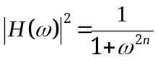
Equation(2.1)
where n is the order of the filter.

Given that a 40dB per decade roll off in magnitude is required above the cuttoff frequency a second order filter is required, hence n = 2 . Looking up the value for the order of the filter in Table(1.1), it can be seen that the transfer function for the low-pass prototype is:-

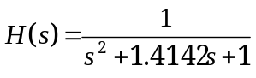
Equation(2.2)

Evaluating (Equation 2.1), for very small values of ω, the amplitude response of the Butterworth filter is a constant at a value of 1. Hence the flatness of the response in the passband. As ω is increased to the extent that ω^{2n} = 1, the amplitude response is halved i.e. 3dB down from the passband. And at higher frequencies the amplitude response is wholly governed by 1/ω⁴.

n
1 | (s+1)
2 | (s² +1.4142s + 1)
3 | (s+1)(s² + s + 1)
4 | (s² + 0.7654s + 1)(s² + 1.8478s + 1)
5 | (s+1)(s² + 0.6180s + 1)(s² + 1.6180s + 1)
6 | (s² +0.5176s + 1)(s² + 1.4142s + 1)(s² + 1.9319)
7 | (s+1)(s² + 0.4450s + 1)(s² + 1.2470s + 1)(s² + 1.8019s + 1)
8 | (s² +0.3902s + 1)(s² + 1.1111s + 1)(s² + 1.6629s + 1)(s² + 1.9616s + 1)
9 | (s+1)(s² + 0.3473s + 1)(s² + 1.0000s + 1)(s² + 1.5321s + 1)(s² + 1.8794s + 1)
10 | (s² + 0.3129s + 1)(s² + 0.9080s + 1)(s² + 1.4142s + 1)(s² + 1.7820s + 1)(s² + 1.9754s + 1)

Table(1.1) Butterworth Quadratics

ii) Transform this low-pass prototype into a low-pass filter with the appropriate bandwidth

Filter coefficients that appear in tables such as Table(1.1) are normalized for cutoff frequencies of 1 radian per second, or ω₀ = 1. Therefore, if these coefficients are used to generate a filter transfer function, the cutoff (or center) frequency of the transfer function will be at ω = 1. This is a convenient way to standardize filter coefficients and transfer functions. If this were not done,
different set of coefficients would be needed for every possible center fre-
quency. Instead, we use coefficients that are normalized for ω₀ = 1 because it is simple to rescale the frequency behavior of a 1 r.p.s. filter. In order to denormalize a transfer function each “s” term is replaced with s/ω₀ , where ω₀ is the desired cutoff frequency. Thus the second-order Butterworth low-pass function

could be denormalised to have the required cut-off frequency of 2kHz by replacing s with s/4000π as below:

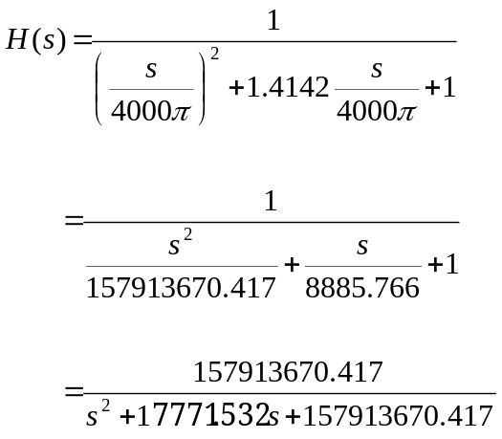

The frequency response can now be verified on MATLAB using the following commands.
MATLAB SCRIPT 2.1

num = [157913670.417]
den = [1 17771.532 157913670.417]
bode (num,den)

The resultant Bode frequency response can be observed in Figure(2.1)

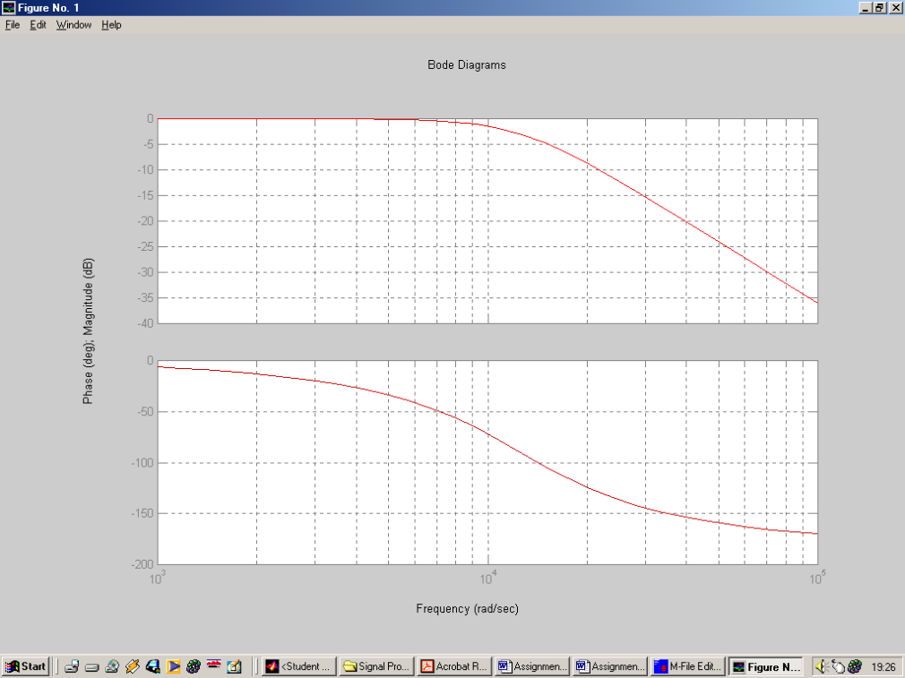

Figure(2.1) Bode Plot of the 2nd order Butterworth system response using MATLAB

Clearly the Bode plot of Figure(2.1) has the correct characteristics as stated in the design specification. The procedure used to denormalise the transfer function of Equation 2 into a user defined filter can be simply achieved in MATLAB by using the Butterworth command.

MATLAB SCRIPT 2.2

[num, den] = butter(2,[2000*2*pi],’s’)
bode (num,den)

By implementing MATLAB SCRIPT 2.2 the Bode Plot of Figure(2.1) is again achieved, hence the Butterworth command eradicates any need for lookup quadratic tables and denormalising.

Chebyshev I/II and Elliptical Filter

There are many other classical filter designs used in electrical circuits. Butterworth aside, the most common of these are the Chebyshev and Elliptical. To create one of these filters commands exist within MATLAB which give the transfer function of the particular filter according to the design specification. The polynomial used to create these filters are again tabulated, but in these two instances I will only use the MATLAB commands.

Evaluating the Chebyshev filter

MATLAB SCRIPT 2.3

[num, den] = cheby1(2,0.9,[2000*2*pi],’s’)
bode (num,den)

Where 2, 2000*2*pi and s are as before but 0.9 is added to specify the allowable pass band ripple in dB. The resultant frequency response can be observed in Figure(2.2).

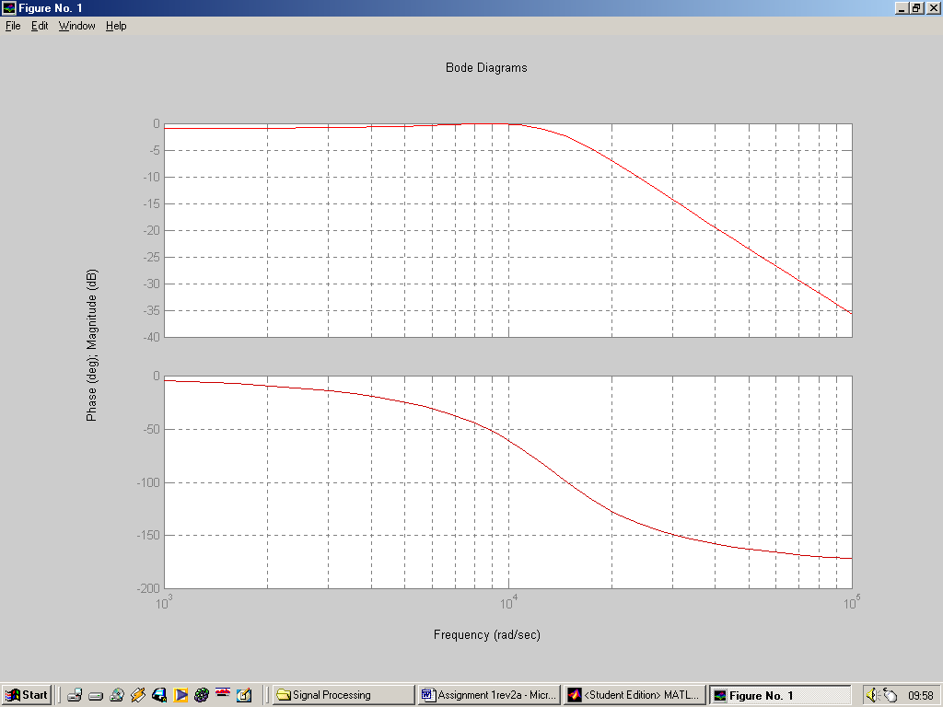

Figure(2.2) Bode Plot of the 2nd order Chebyshev1 system response using MATLAB

The MATLAB command cheby1 signifies that a Chebyshev type 1 filter design is being undertaken in which the passband ripple is controlled (and contrasts with cheby2 which is for a type II design where the stopband ripple is controlled.

Evaluating the Chebyshev filter
MATLAB SCRIPT 2.4

[num, den] = ellip(2,0.9, 50, [2000*2*pi],’s’)
bode (num,den)

Where 2, 0.9, 2000*2*pi and s are as for the Chebyshev filter but 50 is added to specify that, after the initial monotonic increase of attenuation in the stopband to 50dB, stopband ripple is then acceptable so long as the attenuation never falls below 50 dB. The resultant response is shown in Figure(2.3)

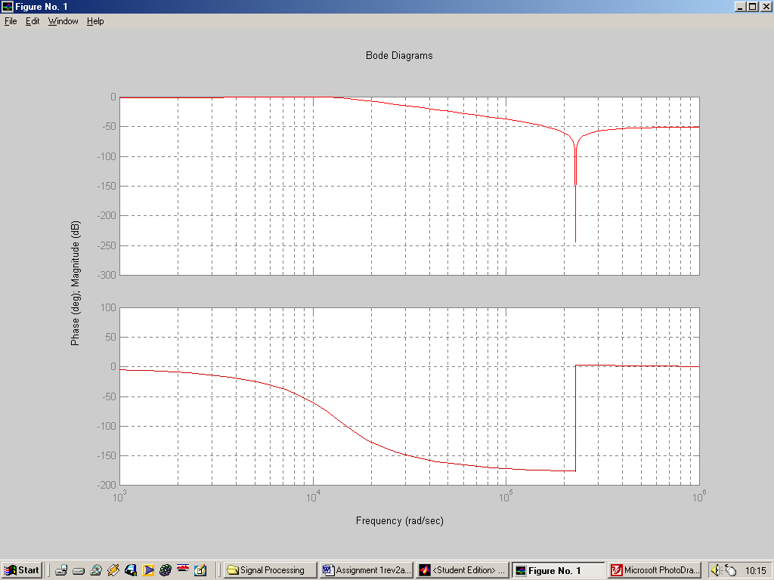

Figure(2.2) Bode Plot of the 2nd order Eliptical system response using MATLAB

- Main Conclusions

In order to fully realise the frequency response of a filter using arbitrary pole-zero placement, (this is attempted in part1 of this report) the amplitude and phase calculations are required. Thankfully the equations used in order to generate the frequency response are at worst trigonometry mathematics. However in this assignment I have evaluated the phase and amplitude response at 14 different values of ω. This Requires 28 separate calculations to achieve an estimate of the frequency response. As can be seen from the Microsoft Excel generated graphs, these are accurate to an extent but do lack definition. Hence to achieve an high level of accuracy, the frequency response would have to be evaluated over a far wider range of ω values. Thankfully there is MATLAB, used to justify these estimates. It does all the hard work for you, all that is needed to generate the frequency response is the transfer function polynomial or the position of the poles and zeros. However, it’s all good and well letting MATLAB do the hard work for you, but if you can’t interpret approximately what the response is going to be in the first instance then the power of MATLAB is wasted.
There are many steps involved in generating circuit component values from an arbitrary pole zero plot. The easiest step in this process is the generation of the passive low pass filter transfer function using the Laplace method. A lot of guess work is involved by the designer. If not very experienced, a long laborious road lies ahead in order to meet specifications. That is mainly all filter design boils down to, i.e. looking at a specification then knowing approximately how many poles or zeros are required then where in the region these must be placed. In accordance with this assignment, three attempts were made to generate the correct response. However, there are many more which I haven’t gave details of (for the sake of readability). Many, many more revisions could have been undertaken in order to achieve an even better response. That’s where the pole zero method lags behind conventional classical methods. There is no standardised polynomial for a 2nd order 2kHz cut-off filter under the arbitrary pole-zero plot method. Different designers will achieve different results, in any case there are so many standardised classical filter designs the pole-zero method is not needed. It does however help to clarify/ give experience to a designer faced with working out the approximate frequency response off hand from a pole zero plot.
Classical filter designs such as the Butterworth (which is detailed in part2 of this report) uses normalised polynomial values for any order system. The calculation used in denormalising the polynomial transfer function to achieve the correct frequency response (as detailed in the specification) is very straight forward. The pole zero placement can then easily be determined (if need be) by factorising the numerator and denominator. Again I could have created an estimate of the frequency response by tabulating for different values of ω. Because I have looked at the Classical filter method at a glance, MATLAB is used instead to generate this. The point is, there are three steps involved in creating this response (as the method is mathematically standardised), there are an infinite amount of routes that can be taken in order to generate a frequency response from an arbitrary pole-zero placement.

- References

  - D.E Gray, ‘Writing a technical Paper’, Physics Education, 1967, Vol.2 p. 81-88
  - System Analysis & Signal Processing, Denbigh, Chapter 12
  - Modern Control Engineering, Ogata, Chapter 8

